**1.Title: Online Insurance Management**



**2.Project Statement:**

The project aims to develop a user-friendly web application that facilitates the

Selection of Job according to the qualification

**Outcomes:**

Allow Customer to easily schedule appointments with preferred Agents.

Provide Agents with a convenient way to manage their appointment schedules.

Improve efficiency in outpatient appointment booking and management.

Enhance patient satisfaction by offering a seamless and user-friendly interface.

1. **Modules to be implemented**
2. User Authentication and Registration
3. Appointment Scheduling Interface
4. Agent Availability Management
5. Plan Information Management
6. Appointment Management
7. Notification System
8. Admin Dashboard
9. **Week-wise module implementation and high-level requirements with output screenshots**

**Milestone 1: Weeks 1-3**

**Module 1: User Authentication and Registration**

* Implement user registration functionality.
* Develop user login mechanism.
* Integrate email verification and password reset features.
* Output screenshot:

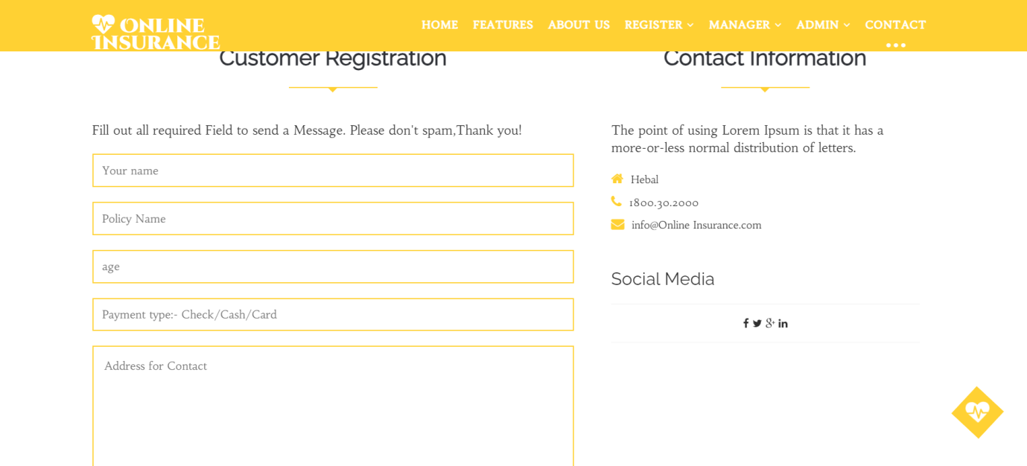

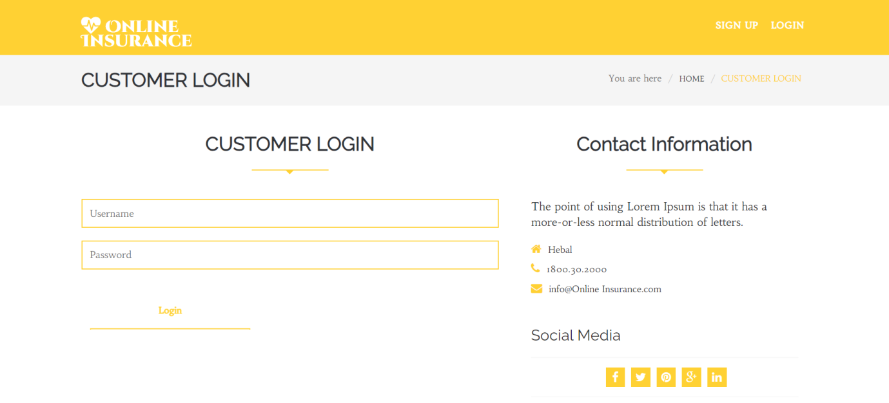

**Module 2: Agent Availability Management**

* Design database schema for storing Agent availability information.
* Develop an interface for Agents to set their availability.
* Implement backend functionality to manage and update Agent availability.
* Output screenshot

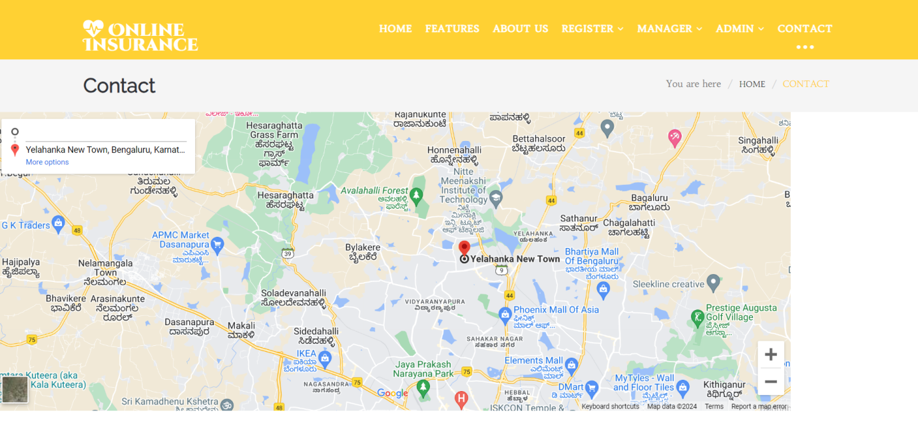

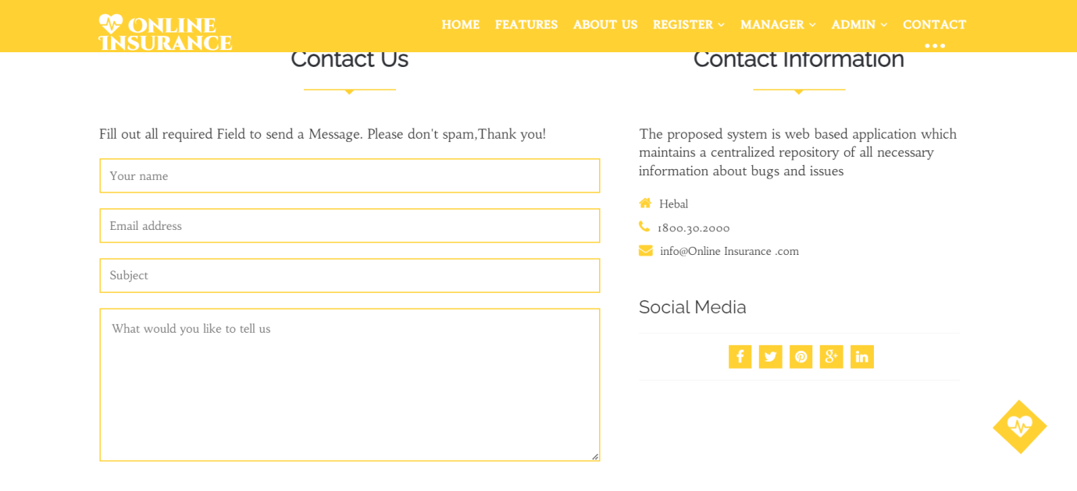

**Milestone 2: Weeks 4-5**

**Module 3: Appointment Scheduling Interface**

* Design and develop the interface for appointment scheduling.
* Implement functionality for users to select Agents, preferred time slots, and reasons for the appointment.
* Integrate the scheduling interface with the backend for storing appointment details.
* Output screenshot

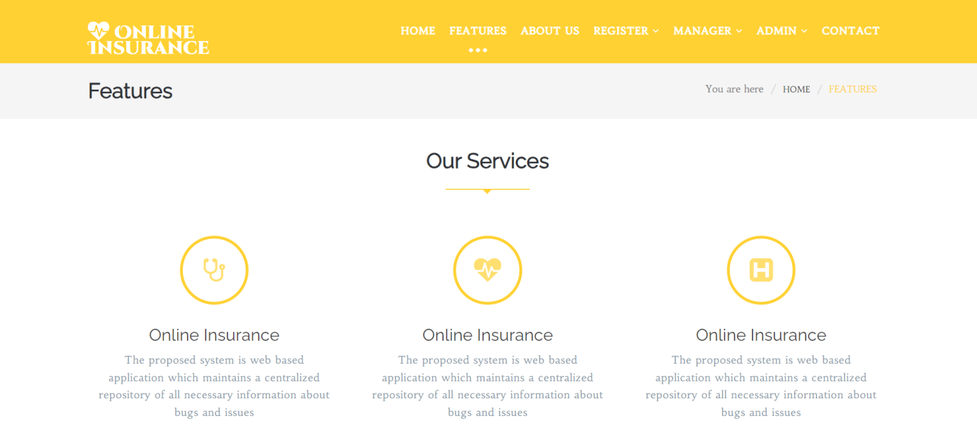

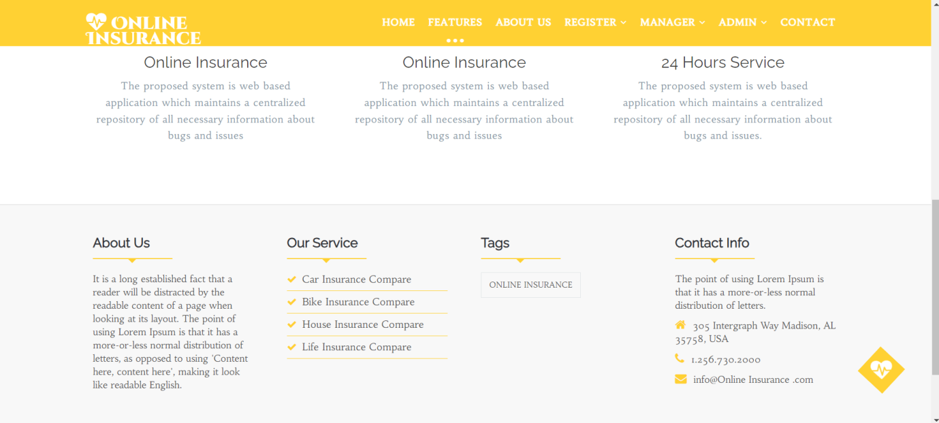

**Milestone 3: Weeks 6-7**

**Module 4: Appointment Management**

* Design database schema for storing appointment details.
* Implement backend functionality for scheduling appointments and preventing conflicts.
* Develop an interface for Agents and Customer to view and manage appointments.
* Output Screenshot:



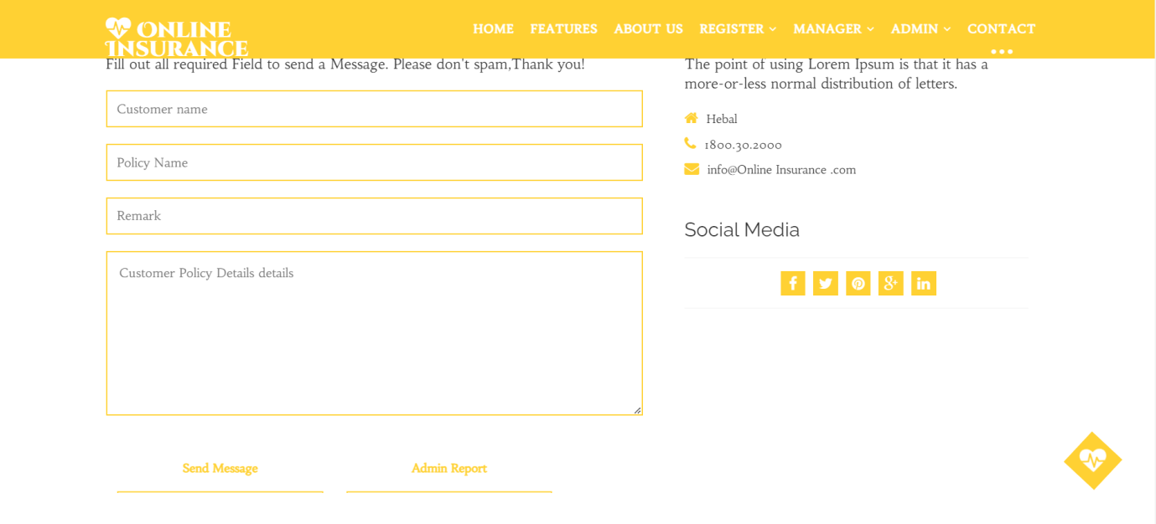

**Milestone 4: Weeks 8-10**

**Module 5: Plan Information Management**

* Design database schema for storing patient information securely.
* Develop functionality for Customer to provide and update their information.
* Implement backend logic for accessing and managing patient information securely.
* Output Screenshot:



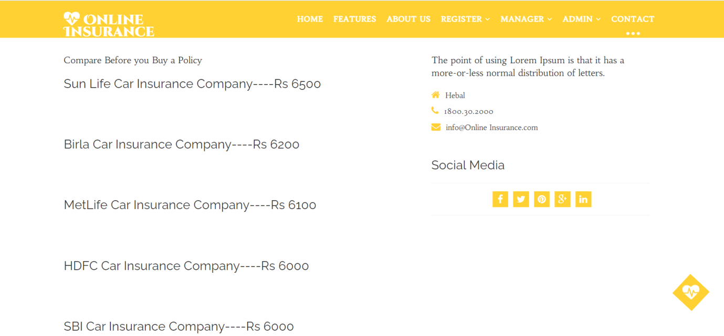

**Module 6: Notification System**

* Integrate email and/or SMS notification services.
* Develop triggers and notifications for appointment reminders, new bookings, and cancellations.
* Implement a system for handling and tracking notifications.
* Output screenshot:

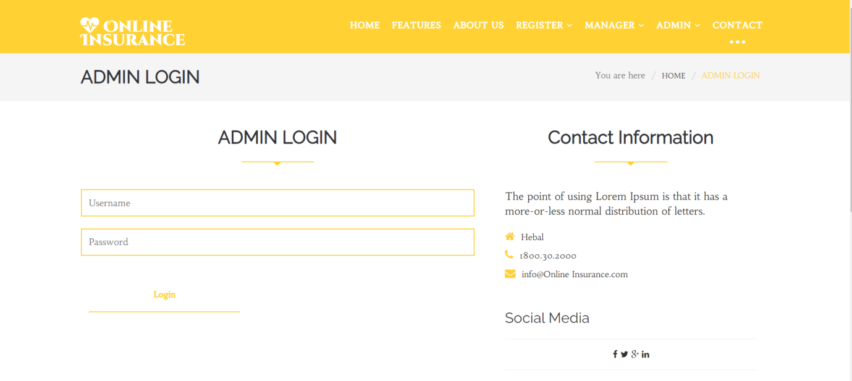

**Module 7: Admin Dashboard**

* Design the layout and functionality of the admin dashboard.
* Implement user management features for admins to add, edit, and delete users.
* Develop modules for managing Agents, appointments, and Plan information.
* Output Screenshot:



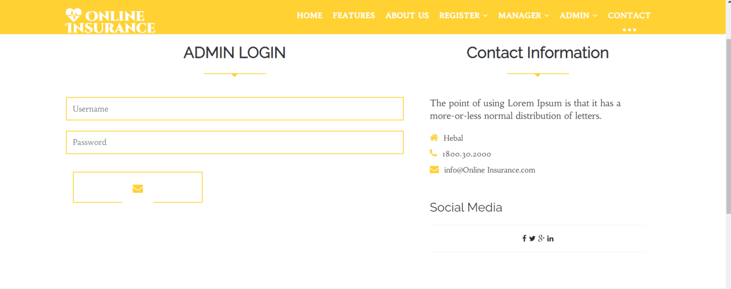

**Evaluation Criteria:**

**Milestone 1 Evaluation (Week 3):**

* Completion of user authentication and registration.
* Successful implementation of Agent availability management functionalities.

**Milestone 2 Evaluation (Week 5):**

* Appointment scheduling interface is fully developed and integrated with the backend.

**Milestone 3 Evaluation (Week 7):**

* Appointment management system is operational, allowing for scheduling and viewing appointments.

**Milestone 4 Evaluation (Week 10):**

* Patient information management, notification system, and admin dashboard are fully implemented and functional.

1. Design diagrams

Class Diagram: Entity classes

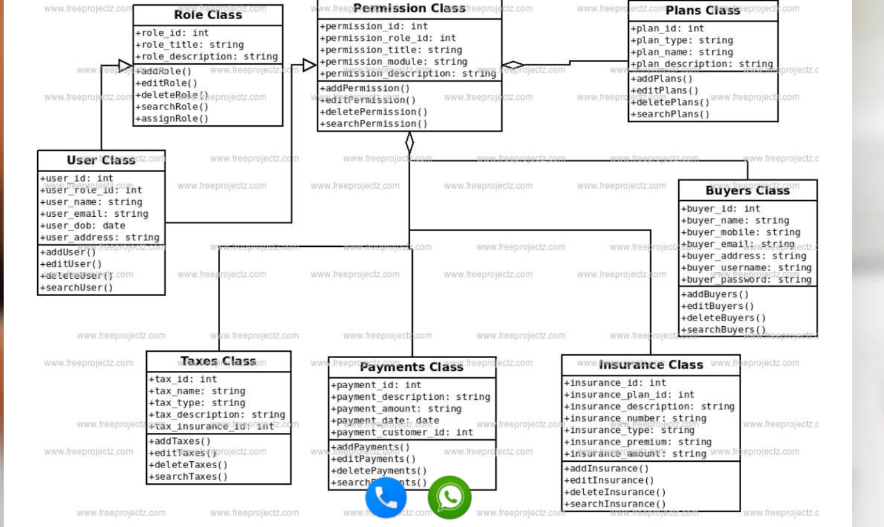

**Output Screenshots:**

1. Dashboard

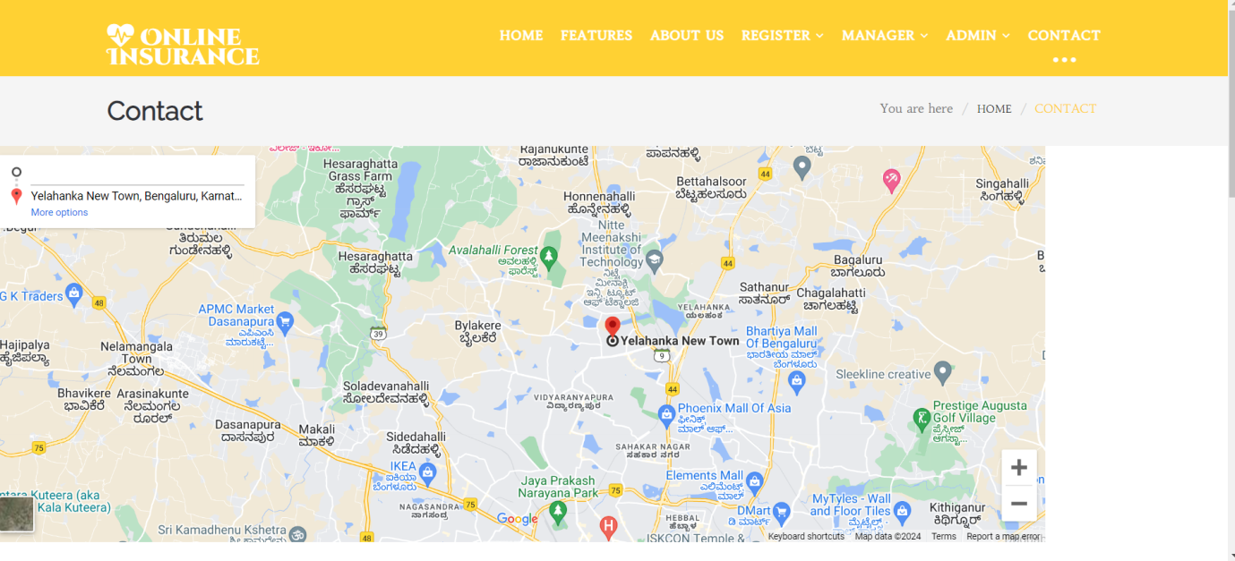

2. Admin Dashboard

